ERD DIAGRAM.

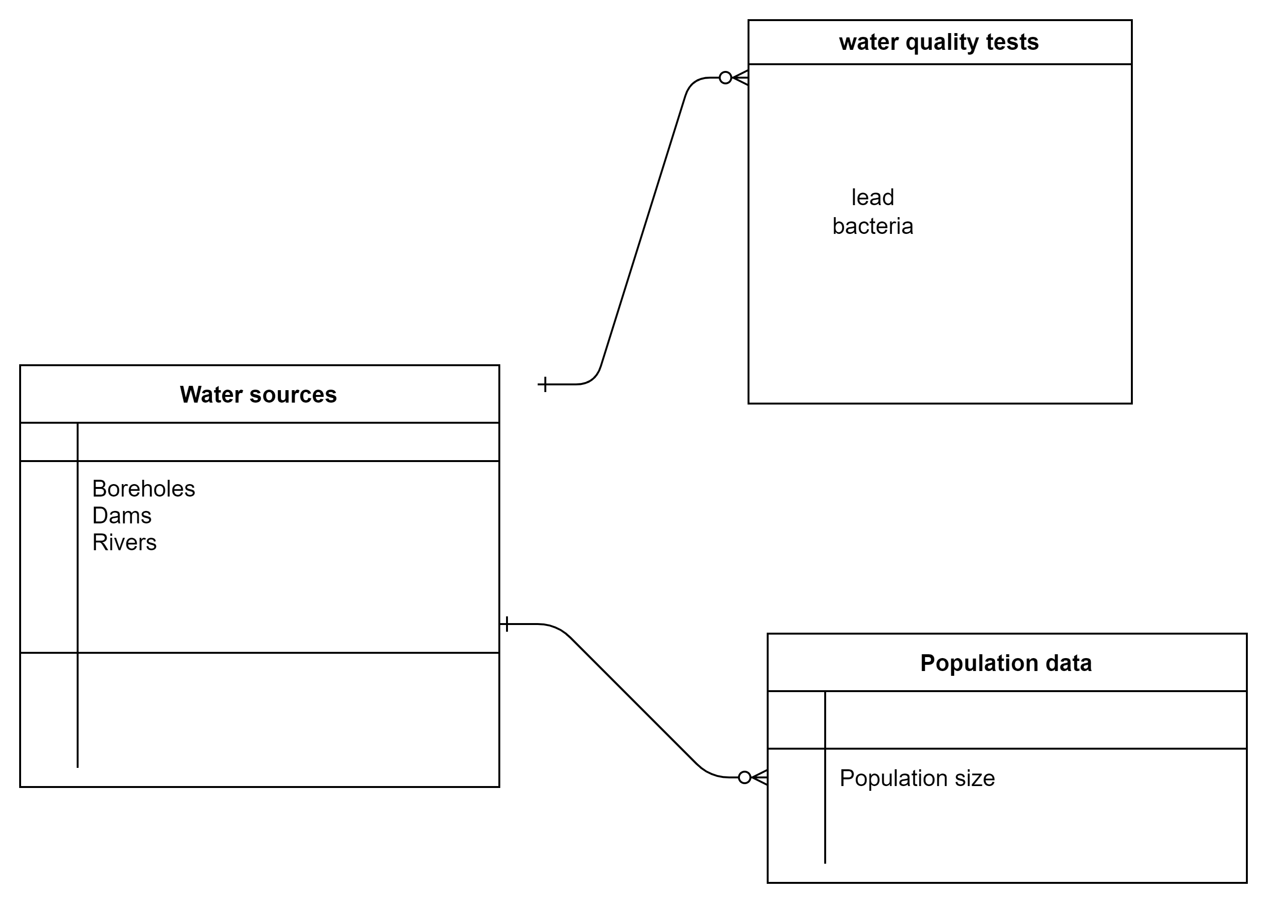

* A water source can be accessed by a variety of population.
* A water source can have multiple quality tests.